AIRCRAFT ENGINE PREDICTIVE MAINTENANCE ANALYSIS

Using Sensor Data to Analyze Engine Health and Remaining Useful Life

Harold Wanton IV
Google Data Analytics Capstone
2026

PROJECT OVERVIEW
This project analyzes aircraft engine sensor data to identify patterns related to engine degradation and Remaining Useful Life (RUL). The analysis uses the NASA C-MAPSS FD001 dataset, which contains operational and sensor measurements from 100 simulated aircraft engines that were operated until failure (NASA, 2025; Saxena et al., 2008).
The main goal was to determine whether sensor measurements and operating cycles could better explain engine health and identify signs of degradation. Using Python and Pandas in Google Colab, I cleaned and analyzed the data and created visualizations to examine relationships between sensor behavior, operating cycles, engine condition, and remaining useful life.

BUSINESS TASK
The business task is to analyze aircraft engine sensor and operating-cycle data to see whether changes in engine performance can help identify degradation and estimate Remaining Useful Life (RUL).
I focused on three main areas: how sensor readings change as an engine approaches failure, which sensors most strongly relate to engine health, and how operating cycles relate to an engine's condition.
The findings can support a predictive-maintenance approach by identifying engines at higher risk that may need closer inspection or maintenance before failure.

DATASET & TOOLS
The analysis uses the NASA C-MAPSS FD001 dataset, a simulated aircraft engine dataset used to study engine degradation and predictive maintenance (NASA, 2025; Saxena et al.,2008). The dataset contains measurements from 100 engines that operated for different numbers of cycles until failure.
The processed dataset contains 20,631 observations and 27 columns. These include engine identifiers, operating-cycle information, three operating settings, 21 sensor measurements, and the calculated Remaining Useful Life (RUL). The engines account for 2,244,815 total operating cycles.
I calculated RUL for each observation by subtracting the current operating cycle from the final operating cycle recorded for that engine. This provides the number of operating cycles remaining before the engine reached the end of its recorded useful life.
TOOLS USED
Python — Data analysis and calculations
Pandas — Data cleaning, transformation, and analysis
Matplotlib — Data visualization
Google Colab — Analysis environment
Google Docs — Final portfolio presentation

DATA CLEANING & PREPARATION
Before starting the analysis, I reviewed the dataset for common data-quality issues. I checked for missing values, duplicate records, incorrect data types, and unusual value ranges.
The dataset contained 0 missing values and 0 duplicate rows. The variables were stored as integer or floating-point data types. I also reviewed descriptive statistics to check variable ranges and distributions.
Several sensor variables remained constant throughout the FD001 dataset and did not provide meaningful variation for correlation analysis. I kept these variables to preserve the original data structure.
I also calculated Remaining Useful Life (RUL) for each engine observation. RUL represents the number of operating cycles remaining before the engine reaches the end of its recorded useful life.

DATA QUALITY RESULTS

Data Quality Check Result
Missing Values | 0
Duplicate | 0
Engines | 100
Observations | 20,631
RUL Calculated | Yes

ANALYSIS & FINDINGS

Question 1
How do sensor readings change as an engine approaches failure?
The sensor readings changed as the engines accumulated operating cycles and their Remaining Useful Life (RUL) decreased. Several sensors showed noticeable relationships with RUL, suggesting their measurements can help identify signs of engine degradation.

Sensor 11 had one of the strongest relationships with RUL, followed by sensor 4 and sensor 15. Sensor 11 had a correlation of -0.696 with RUL. The negative correlation means that higher Sensor 11 readings were generally associated with lower remaining useful life in this dataset.
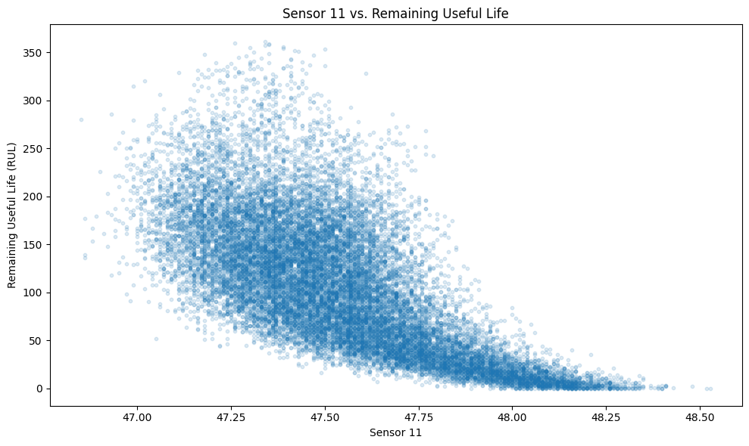
Figure 1. Sensor 11 measurements compared with Remaining Useful Life.

This makes Sensor 11 a useful sensor to monitor for changes as an engine approaches the end of its recorded useful life.

Question 2
Which sensors are the best indicators of engine health or impending failure?
The correlation analysis showed that several sensors had strong relationships with Remaining Useful Life (RUL). Sensor 11 had the strongest negative correlation with RUL at -0.696, followed by Sensor 4 at -0.679 and Sensor 15 at -0.643.

Sensors 2, 17, and 3 also had relatively strong negative relationships with RUL. On the positive side, Sensors 12, 7, 21, and 20 showed strong positive relationships with RUL.

Based on the results, Sensors 11, 4, and 15 stood out as the strongest individual sensor indicators in this analysis. However, correlation alone does not show that a sensor directly causes engine degradation or can predict failure on its own. The sensors are better viewed as indicators that can be monitored along with operating-cycle information and other sensor measurements.

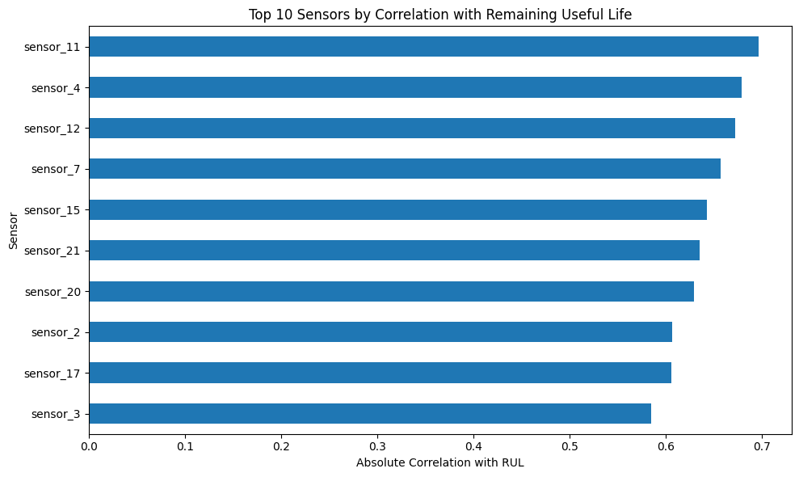
Figure 2. Top 10 sensors ranked by absolute correlation with Remaining Useful Life.

Question 3
How does the number of operating cycles affect an engine’s condition?
Operating cycles had a strong relationship with Remaining Useful Life (RUL). The correlation between operating cycles and RUL was -0.736. This means that as an engine accumulated more operating cycles, its remaining useful life generally decreased.

The results show that operating-cycle information can be useful when evaluating engine condition. However, the engines in this dataset did not all have the same useful life. Because of this variation, consider operating cycles alongside sensor measurements rather than using them as the only measure of engine health.

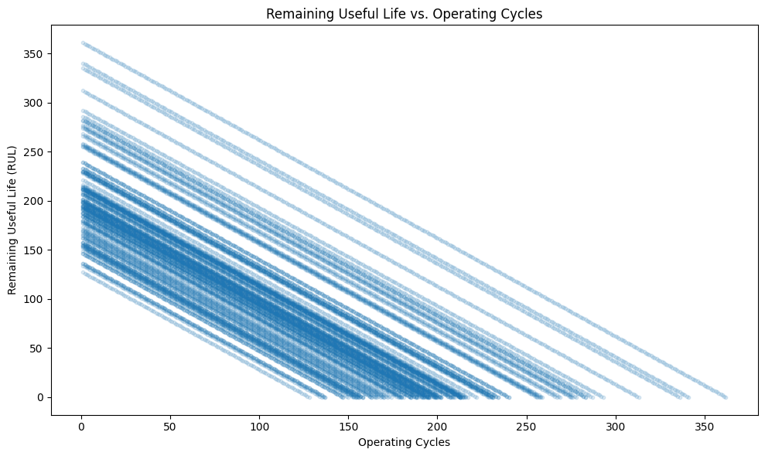
Figure 3. Remaining Useful Life compared with operating cycles.

Question 4 — Useful Life
Which engines have the shortest and longest useful lives?
The engines did not all operate for the same number of cycles before reaching the end of their recorded useful life. Engine 39 had the shortest useful life at 128 operating cycles, while Engine 69 had the longest at 362 operating cycles.
That is a difference of 234 operating cycles between the two engines. This variation shows that engine useful life can differ considerably, which matters when scheduling maintenance.
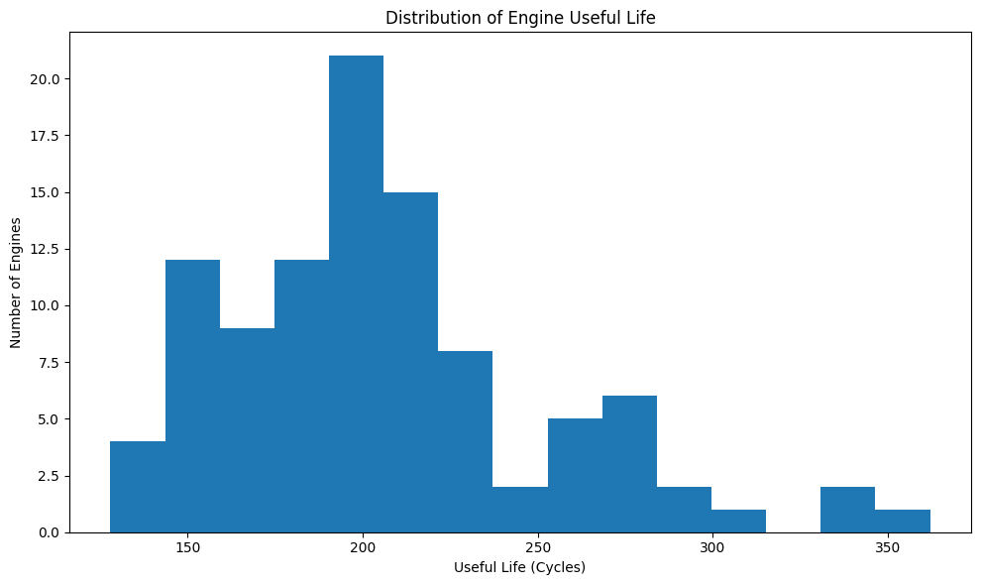
Figure 4. Distribution of useful life across the 100 engines.

Question 5 — Predictive Patterns
Can we identify patterns in the data that could help predict when an engine is approaching failure?
The data shows several patterns that could help identify engines approaching failure. Operating cycles had a strong relationship with RUL, and several sensors also showed strong relationships with remaining useful life.
Sensors 11, 4, and 15 had some of the strongest negative correlations with RUL. Sensors 12, 7, 21, and 20 showed strong positive relationships. Looking at these measurements together with operating cycles gives more information about engine condition than looking at one variable alone.
A predictive model could use these variables together to estimate RUL and identify engines that may need additional inspection or maintenance. The results provide a starting point for building that type of model.
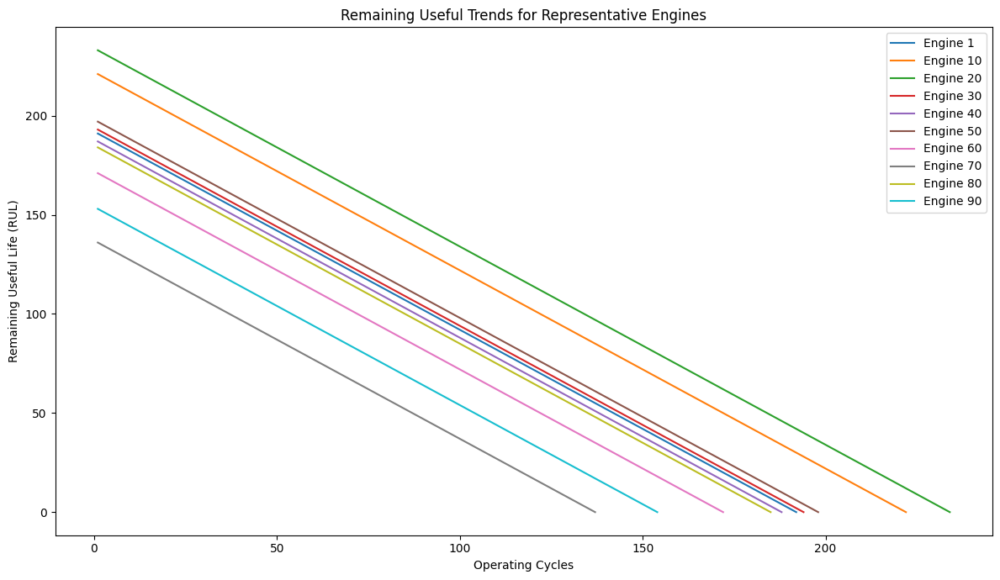
Figure 5. Remaining Useful Life trends for representative engines.

Question 6
What recommendations can we make for predictive maintenance based on the findings?
Based on the results, a condition-based predictive maintenance approach would be more useful than relying solely on a fixed maintenance schedule (NASA, 2015). Sensors 11, 4, and 15 stood out in this analysis because they had some of the strongest relationships with Remaining Useful Life (RUL).
A predictive model could combine these sensor measurements with operating-cycle information to estimate RUL and identify engines that may need additional inspection. This could help maintenance teams focus their attention on engines showing stronger signs of degradation.
The variation in engine useful life also supports using condition information when making maintenance decisions (NASA, 2015). Since the engines in this dataset did not all reach the end of their useful life at the same number of cycles, maintenance decisions should consider sensor readings and engine condition instead of relying only on a fixed cycle limit.

KEY FINDINGS
The analysis found several clear patterns in the relationship between engine operating cycles, sensor measurements, and Remaining Useful Life (RUL).
1. Operating cycles are strongly associated with Remaining Useful Life
Operating cycles had a correlation of -0.736 with RUL. As operating cycles increased, remaining useful life generally decreased.
2. Sensor 11 was the strongest individual sensor indicator
Sensor 11 had a correlation of -0.696 with RUL. This was the strongest negative correlation among the individual sensors examined.
3. Sensors 4 and 15 also showed strong relationships with RUL
Sensor 4 correlated at -0.679, while Sensor 15 correlated at -0.643. These sensors, along with Sensor 11, were the strongest individual sensor indicators in this analysis.
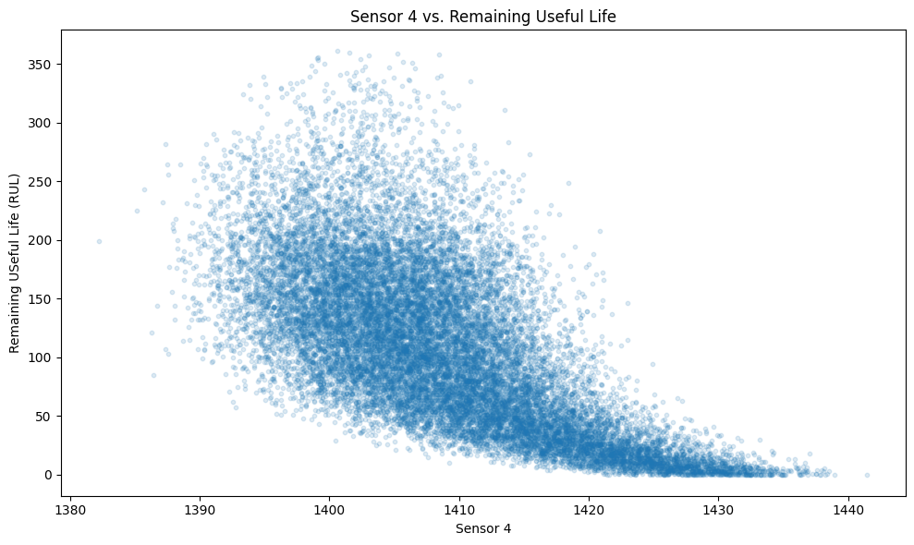

Figure 6. Sensor 4 measurements compared with Remaining Useful Life.
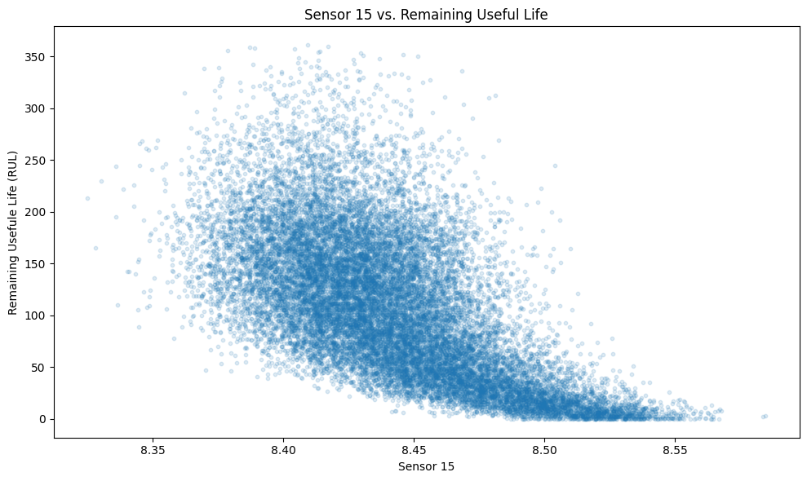
Figure 7. Sensor 15 measurements compared with Remaining Useful Life.
4. Engine useful life varied significantly
Engine 39 had the shortest useful life at 128 cycles, while Engine 69 had the longest at 362 cycles. The difference between them was 234 operating cycles.
5. Multiple variables should be considered together
The results show that operating cycles and individual sensor measurements both provide useful information about engine condition. Using several of these variables together could provide a better basis for estimating RUL than relying on a single measurement.

Conclusion
The analysis showed that aircraft engine sensor data can help explain changes in engine condition and Remaining Useful Life (RUL). Operating cycles had a strong relationship with RUL, and several sensor measurements also showed strong relationships with remaining useful life.
Sensors 11, 4, and 15 had the strongest individual sensor relationships in this analysis. Operating cycles also strongly correlated with RUL. At the same time, the engines did not all have the same useful life, which shows why engine condition should be considered instead of relying only on a fixed maintenance interval.
The results support using multiple sensor measurements together with operating-cycle information when evaluating engine condition. A future predictive model could use these variables to estimate RUL and help identify engines that may need additional inspection or maintenance (NASA, 2015).
This project gave me practical experience using Python, Pandas, and Matplotlib to clean, analyze, and visualize a real-world-style dataset. It also showed how data analysis can turn raw sensor measurements into information that supports maintenance decisions.

Project Takeaway
Use the data to move from scheduled maintenance toward condition-based decisions.

References
NASA. (2025). C-MAPSS jet engine simulated data. NASA Open Data Portal.
Saxena, A., Goebel, K., Simon, D., & Eklund, N. (2008). Damage propagation modeling for aircraft engine run-to-failure simulation. Proceedings of the 1st International Conference on Prognostics and Health Management (PHM08), Denver, CO.
NASA. (2015). NASA Procedural Requirements 8831.2F: Facilities maintenance and operations management. NASA.

